**ASSIGNMNET-1**

**SE- OVERVIEW OF IT INDUSTRY**

**Q-1 What is software? What is software engineering?**

--> Software is considered to be collection of executable programming code, associated libraries and documentations.

- Software, when made for a specific requirements is called software product. Engineering on the other hand, is all about developing products, using well-defined, scientific principles and methods.

**Q-2 Explain types of software?**

--> Two Main Types of Software :-

1. Application Software
2. System Software

- Other Types of Software Are:-

1.Driver Software

2.Middleware

3. Programming Software

1. Application Software:-

- The most common type of software, application software is a computer software package that performs a specific function for a user , or in some cases, for another application.

- An application can be self-contained, or it can be a group of programs that run the application for the user.

- Ex:- Microsoft Office, Powerpoint, paint etc..

1. System Software:-

- These Software Programs are designed to run a computer’s application programs and hardware.

- System Software coordinates the activities and function of the hardware and software.

- The OS is the best example of system software; it manages all the other computer programs.

- Ex:- Notepad, Calculator etc..

1. Driver Software:-

- Also known as device drivers, this software is often considered a type a system software.

- Device drivers controls the devices and peripherals connected to a computer, enabling them to perform their specific tasks.

- Ex:- Audio Driver, Video Driver etc..

1. Middleware:-

- The term middleware describes software that mediates between application and system software or between two different kinds of application software. For example, middleware enables Microsoft Windows to talk to Excel and Word.

- Ex:- database middleware, application server middleware

1. Programming Software:-

- Computer programmers use programming software to write code. Programming software and programming tools enable developers to develop, write, test and debug other software programs.

- Example of programming software include assemblers, compilers, debuggers and interpreters.

- Ex:- Turbo c, Eclipse, Sublime etc..

**Q-3 What is SDLC? Explain each phase of SDLC**

--> SDLC:-

- The Software Development Life Cycle(SDLC) refers to a methodology with clearly defined processes for creating high-quality software.

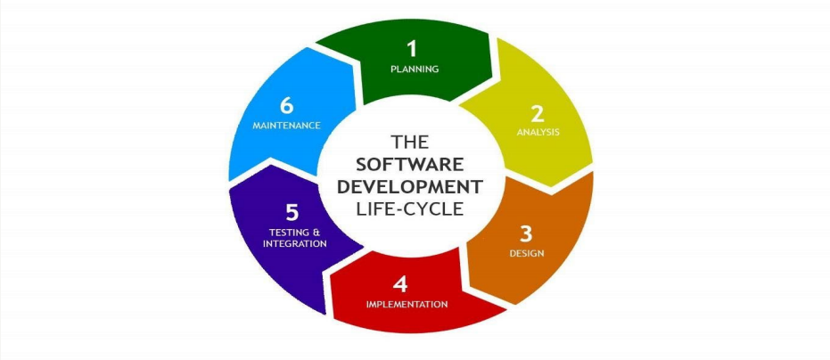

- The SDLC methodology focuses on the following phases of software development:

- 1. Requirement Gathering and Analysis

- 2. Designing

- 3. Implementation

- 4. Testing

- 5. Deployment

- 6. Maintenance

1. Requirement Gathering and Analysis:-

- This phase involves gathering information about the software requirements from stakeholders, such as customers, end-users, and business analysts.

1. Designing:-

- In this phase, the software design is created, which includes the overall architecture of the software, data structures, and interfaces. It has two steps:

* High-level design(HLD): It gives the architecture of software products.

* Low-level design(LLD): It describes how each and every feature in the product should work and every component.

1. Implementation:-

- The design is then implemented in code, usually in several iterations, and this phase is also called as Development.

- Things you need to know about this phase:

This is the longest phase in SDLC model.

This phase consists of Front end+ Middleware+ Back-end.

* In Front-end: Development of coding is done even SEO settings are done.

* Middleware: They connect both the front end and back end.

* In the Back-end: A database is created.

1. Testing: -

- The software is thoroughly tested to ensure that it meets the requirements and works correctly.

1. Deployment:-

- After successful testing, The software is deployed to a production environment and made available to end-users.

1. Maintenance:-

- This phase includes ongoing support, bug fixes, and updates to the software.

- There are different methodologies that organizations can use to implement the SDLC, such as Waterfall, Agile, Scrum, V-Model, and DevOps.

**Q-4. What is DFD? Create a DFD diagram on Flipkart**

**-->** DFD stands for Data Flow Diagram. It’s a visual representation that illustrates data moves within a system or process. DFDs uses symbols to represent processes, data sources, data destinations, data flows, and more. They are commonly used in system analysis and design to model the flow of data and help understand how different components of a system interact.

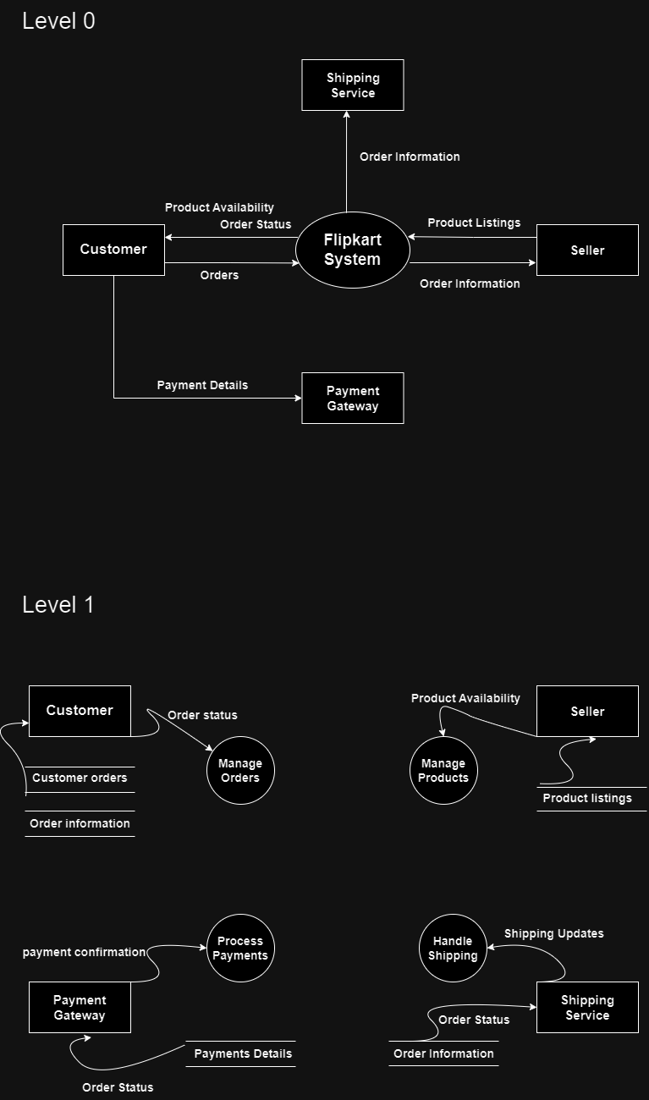

**Q-5. What is Flow Chart? Create a flowchart to make addition of two numbers**

**-->** A Flowchart is a graphical representation of a process, system, or algorithm using various symbols and arrows to depict the sequence of steps, decisions, and interactions. Flowcharts are widely used in various fields to visually represent the flow of activities, information, or materials within a system. They are a powerful tool for both planning and communicating complex processes.

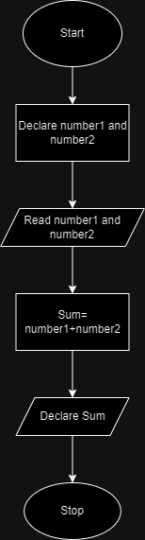

**Q-6. What is Use case Diagram? Create a use-case on bill payment on Paytm**

--> A Use case diagram is a type of visual representation used in software engineering and system design to illustrate how different users or external systems interact with a system or software application. It helps to define the functional requirements of the system by showing various use cases, actors(users or external entities), and their interactions.

